|  |  |
| --- | --- |
| **Experiment Number** | **6** |
| **Date of Experiment** |  |
| **Date of Submission** |  |
| **Name** | **NAZHEEF BISWAS** |
| **Roll Number** | **2230029** |
| **Section** | ECS-01 |

**Aim of The Experiment :-**

Overview of DSP processor kit and Code Composer Studio (CCS v-5) & generation of various types of signals using DSK-TMSC6713 processor kit.

**Equipment and Software Required:-**

The Equipment and Software required are as follows:

1. DSP processor kit
2. Code Composer Studio (CCS v-5)

**Code:**

1. unit impulse signal:

#include<stdio.h>  
int n,k;  
int N=30;  
int y[30];  
void main()  
{  
for(k=0;k<=30;k++)  
{  
y[k]=0;  
}  
y[0]=1;  
for(n=0;n<=N;n++)  
{  
printf("%d\n",y[n]);  
}  
}

1. unit step signal:

#include<stdio.h>  
int n,k;  
int N=30;  
int y[30];  
void main()  
{  
for(k=0;k<=30;k++)  
{  
y[k]=1;  
}  
for(n=0;n<=N;n++)  
{  
printf("%d\n",y[n]);  
}  
}

1. ramp step signal:

#include<stdio.h>  
int n,k;  
int N=30;  
int y[30];  
void main()  
{  
for(k=0;k<=30;k++)  
{  
y[k]=k;  
}  
for(n=0;n<=N;n++)  
{  
printf("%d\n",y[n]);  
}  
}

**Block diagram:**

1. Unit Impulse Signal

Graph (Discrete):

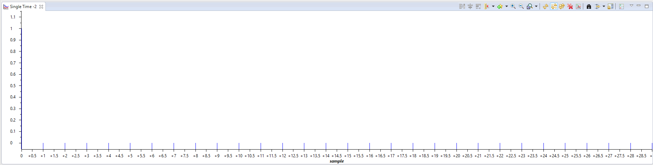

Graph (Line):

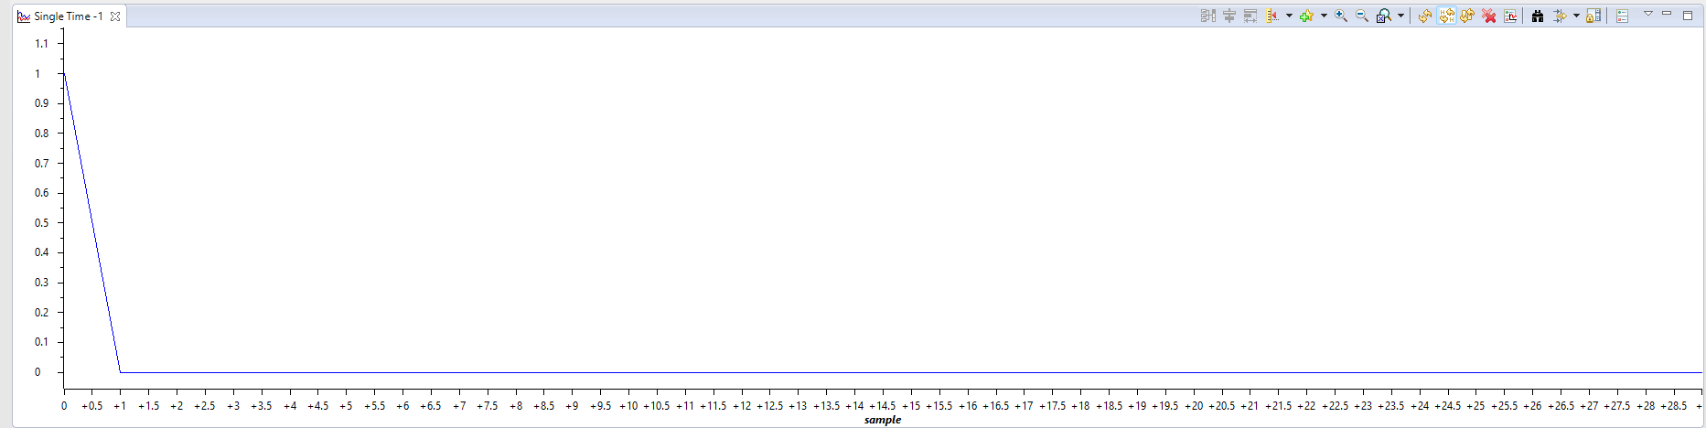

1. Unit Step Signal

Graph (Discrete):

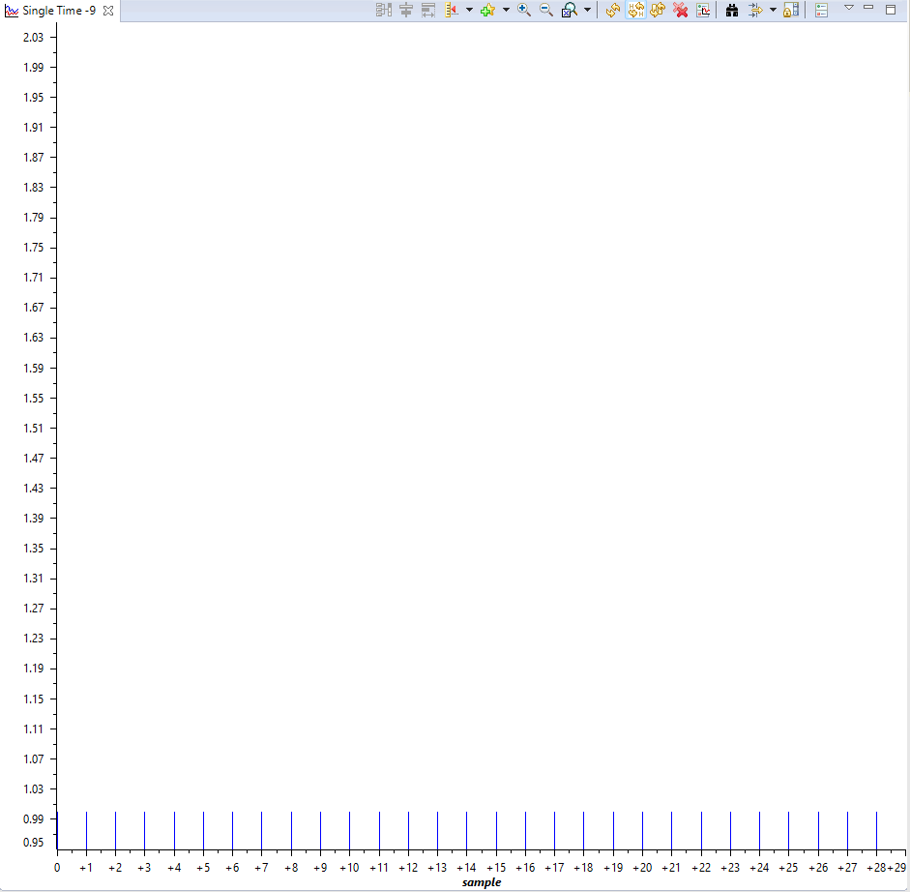

Graph (Line):

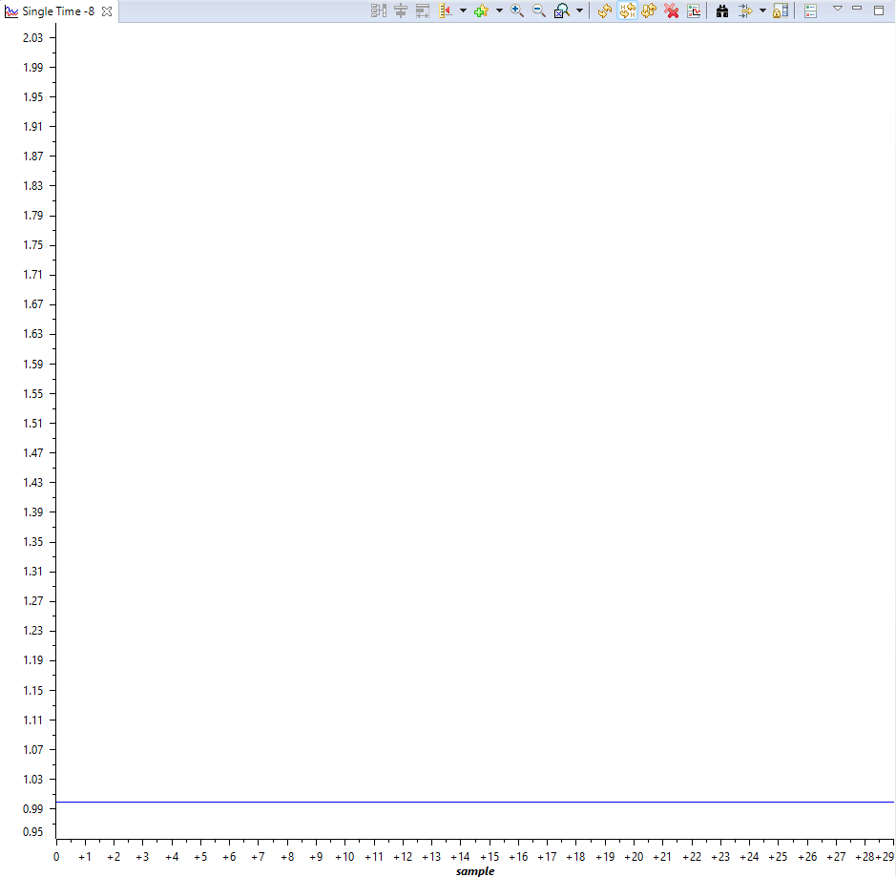

1. Ramp Signal

Graph (Discrete):

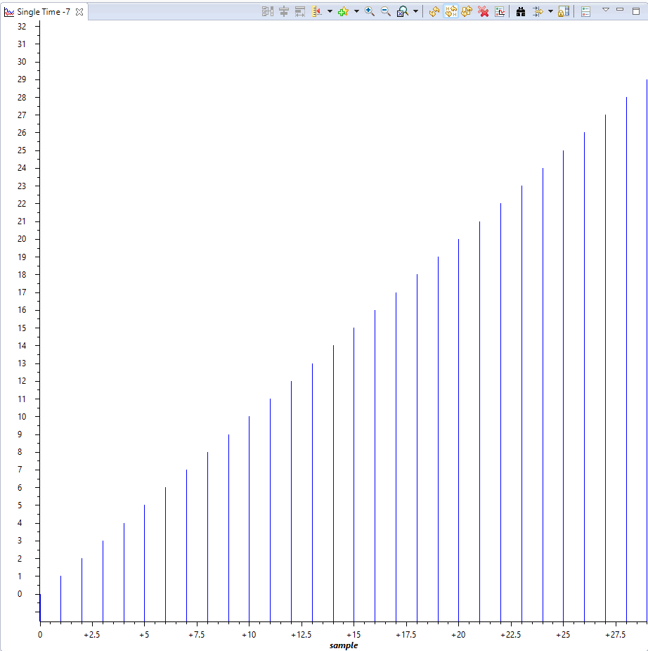

Graph (Line)

: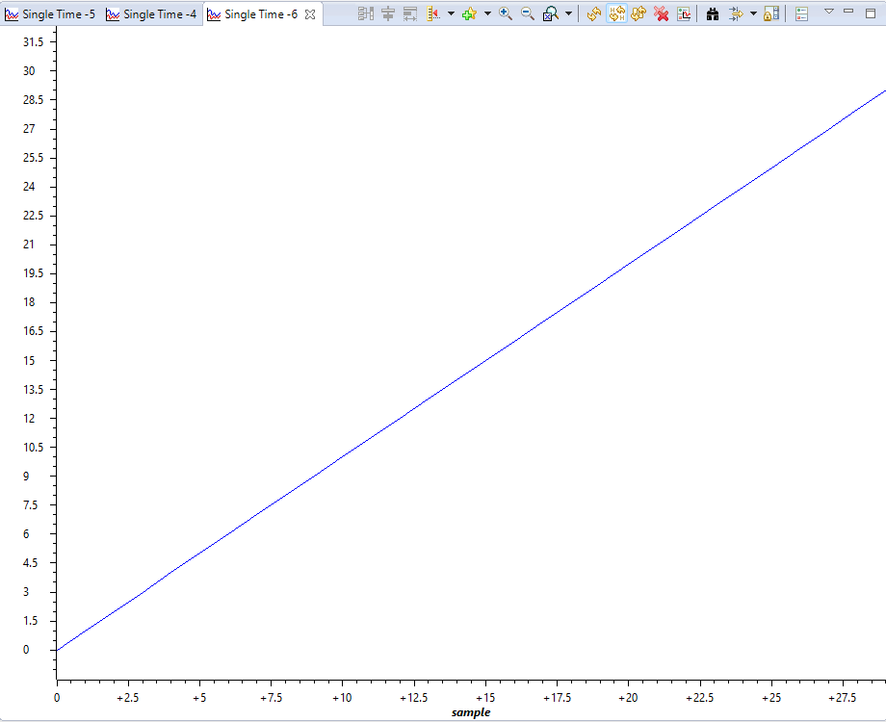

**Discussion or Inference of the experiment:**

discussion :In this experiment, we used a DSP processor kit  with the assistance of CCS v-5  to generate Unit impulse, Unit step, and Ramp signal.

We used the C programming language to script the code. Additionally, we produced line and discrete graphs.for the signals mentioned earlier.

**Conslusion:**

We learned how to set up a DSP processor kit (, connect it to a computer, and use CCS to run code on the hardware from this experiment. We conducted the experiment using the theory of "for" loops and array implementations in C programming, and we examined the plots and console outputs. We gained knowledge of the characteristics and purposes of the above-mentioned signals.